Dear Friends,
Welcome to the latest update from NHS East Riding of Yorkshire CCG. The update below is full of the latest news and events from the local NHS and our partners. Please feel free to forward this on to someone you know to help them access help or support.

‘Help Us, Help You’ - Cancer-Earlier Diagnosis
NHS England & NHS Improvement has launched a new phase of the ‘Help Us, Help You’ campaign taking a radically different approach to detecting cancer earlier for patients, when it is easier to treat.
The campaign aims to address the barriers to people coming forward early by encouraging those who have noticed something in their body that doesn’t feel right and are worried it could be cancer to contact their GP practice. The campaign will reassure people by highlighting that most people who are referred for tests by their GP find out it’s not cancer and that finding out sooner is always better.
The campaign is running in March and is the first ‘Help Us, Help You’ cancer campaign to focus on tackling the ‘fear’ of cancer rather than specific symptoms.
NHS England and NHS Improvement Delivery Plan for Tackling the COVID-19 Backlog of Elective Care
The extraordinary achievements of staff over the last two years are testament to their determination and resilience. NHS teams have provided expert care to more than 600,000 patients with COVID-19 since the beginning of the pandemic, but despite this effort, dealing with the pandemic has inevitably had an impact on the amount of planned care the NHS has been able to provide, resulting in longer waits for many patients.
The pandemic has shown how the NHS can deliver transformational change for patients when needed. Whilst colleagues in every part of the country are working hard to recover elective services, significant additional government funding for elective recovery presents opportunity to build on this success.
The Delivery Plan for Tackling the COVID-19 Backlog of Elective Care sets out plans for the NHS to tackle the COVID backlog in the months and years to come. It focuses on four areas of delivery:
Increasing health service capacity | Prioritising diagnosis and treatment | Transforming the way we provide elective care | Ensuring better information and support to patients
The plan sets out how the NHS will deliver nine million more tests and checks per year by 2025. This means that over a three-year period, patients will be offered around 17 million more diagnostic tests – an increase in capacity of a quarter compared with the three years prior to the pandemic.
To reach these targets, more than 100 diagnostic centres will be rolled out, and more surgical hubs will also be added to the network of 122 already operating across the country. The hubs focus on high-volume routine surgery so more patients can get seen more quickly, making efficient use of taxpayer resources, and creating extra capacity so emergency cases do not disrupt operations and cause cancellations or delays.

Humber Teaching NHS Foundation Trust Stakeholder Newsletter
Click here to read the latest stakeholder newsletter from Humber Teaching NHS Foundation Trust. In this issue:
- Welcoming a new Non-Executive Director
- Local organisations coming together to improve breastfeeding awareness in the East Riding.
- Mental Health Nurse Day 2022
- Latest updates and campaigns

Could you become an Age UK befriender?
One of the ways Age UK tries to combat loneliness in later life is through a friendship service. This is delivered either via telephone befriending and face-to-face befriending. They currently have a significant need for additional befrienders to join their team. You can find out more about getting involved online here.
Cancer Champion training available
In January, the Cancer Champion Programme reached a very important milestone with 3,000 people in Humber, Coast and Vale completing the training to become a ‘cancer champion’. The programme aims to raise awareness of the early signs and symptoms of cancer, promote the national screening programmes and early detection, as well as help to normalise conversations about cancer. Visit the Humber Coast and Vale website to read the story in full.
If you would like to become a Cancer Champion, virtual training sessions are now available throughout March.
- Monday 7th March at 14:00
- Tuesday 8th March at 18:30
- Thursday 10th March at 09:30
- Tuesday 15th March at 15:00
- Friday 18th March at 11:30
- Wednesday 23rd March at 10:00
- Monday 28th March at 12:00
The sessions are suitable for anyone and everyone, with no prior knowledge of cancer being required. After each session every attendee receives links to the videos shared and a digital Cancer Champion handbook as well as a Cancer Champion certificate and badge. All training is free, click here to book a session.
To find out more about Cancer Champion training, please click here.
Help! Talking therapies available to support your mental health
On Monday 17 January, NHS England and NHS Improvement launched a new mental health campaign to highlight that feelings of anxiety and depression can affect us all – and the NHS is here to help.
The NHS provides a range of talking therapies for common mental health issues such as anxiety and depression, which are free, effective and confidential.
Famous faces from across music and radio, including Craig David, Tom Grennan, Laura Mvula, Nicola Roberts, Ella Henderson, Max George, as well as an NHS therapist and real people who have benefited from the NHS mental health talking therapy services are supporting the campaign in a powerful new video featuring the lyrics of the Beatles’ song ‘Help!’, which calls on people who are struggling to reach out for support through NHS services - either by referring themselves, or by contacting their GP who can also refer them.
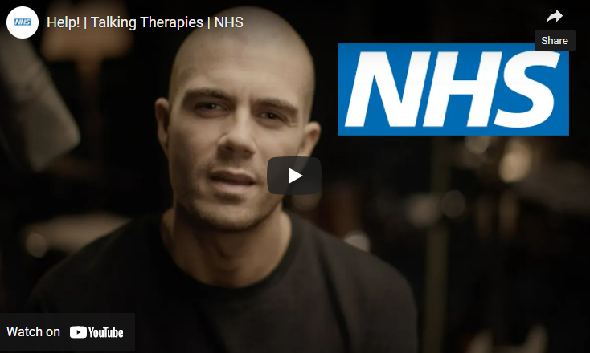
Visit nhs.uk/help for more information.
Bowel Cancer UK – Colonoscopy Confidence campaign
Bowel Cancer UK know some people feel anxious or worried when they’re told they need a colonoscopy but it’s important to have this test if they’re referred. Unfortunately, this can often lead to people missing their appointments.
They have now launched a campaign to try to understand patient barriers to attending a colonoscopy and aim to tackle them with advice and information. The Bowel Cancer UK website has lots of helpful information, advice and also features snapshot films of people who have had the procedure, talking about their experiences.
Walking Football in Hull and the East Riding of Yorkshire
Find the 14,000 men
Why we’re backing Prostate Cancer UK & NHS England’s new campaign.
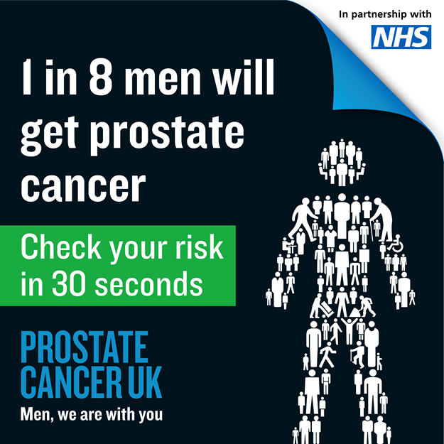
Prostate cancer is more common than you think. It’s the most common cancer in men. 1 in 8 men will get prostate cancer. That could be a dad, uncle, brother, partner or best friend. It’s why Prostate Cancer UK and the NHS have joined forces to launch a campaign to find the 14,000 men who have not started treatment for prostate cancer since the beginning of the pandemic.
Early diagnosis saves lives
New figures show that prostate cancer accounts for a third of those not treated for cancer compared to before the pandemic. Prostate cancer is very treatable if caught early. It’s important for men to know their risk because early prostate cancer often has no symptoms.
Joe Appiah, from Bromley, was diagnosed with prostate cancer during the pandemic. He didn’t have symptoms. “I’d seen adverts about prostate cancer, but I didn’t know how badly black men were affected, or how to get a test. I didn’t have symptoms and wasn’t aware of any family history. So, until my friend told me to speak to my GP, I didn’t think about it – especially with Covid too. My friend saved my life. Thanks to him it was caught just in time.”
Check your risk and share the risk checker with loved ones – it takes 30 seconds and could save lives. Visit Prostate Cancer UK online.
NHS Blood and Transplant - can you help by giving blood?
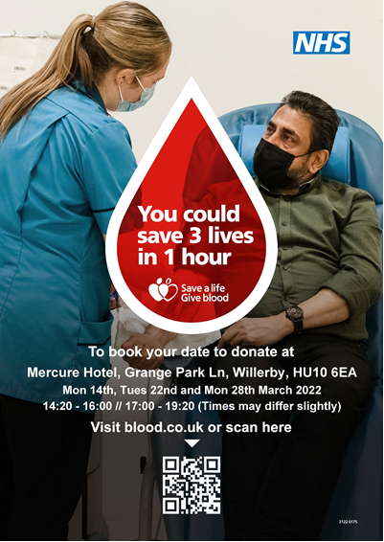

Hull 4 Heroes support group for veterans in Hull and East Riding of Yorkshire

Local charity Hull 4 Heroes is running support groups for serving armed forces, ex-serving and families/partners of those that are serving and have served. Ex-service personnel run a men’s talking group and a women’s talking group that provides a safe space for people to come together, understand each other and listen.
10% of our local population across Hull and East Riding are ex-service personnel who could benefit from the support offered at these groups.
The men’s talking group meets every Wednesday from 6pm onwards at the the Hull 4 Heroes Offices, 7 Whitefriargate, Hull, HU1 2ER
The Lisa’s Ladies women’s talking group meets every Wednesday 12-2pm (subject to change) at the Hull 4 Heroes Offices, 7 Whitefriargate, Hull, HU1 2ER
For further information please contact helen.skinner@hull4heroes.org.uk or paul.matson@hull4heroes.org.uk, alternatively call 01482 534483.
Get involved and share your views
Improving Access in the East Riding – your opinion matters
If you've had an appointment within the Improving Access service in the East Riding of Yorkshire, we would love to hear your feedback by filling in this short survey.

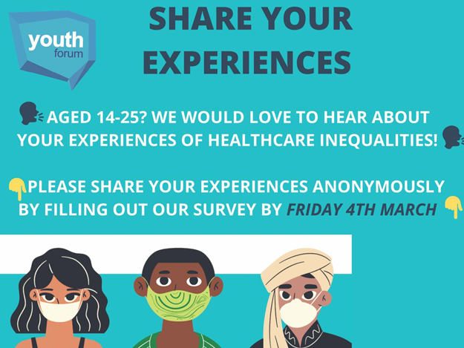
NHS Youth Forum - healthcare inequalities survey
The NHS England Youth Forum is running a project on healthcare inequalities. They want to hear directly from young people about how healthcare inequalities have affected them and how healthcare services can improve to minimise the effect of these inequalities.
This is a great opportunity for young people to engage in a project created by young people, for young people, that will positively influence the healthcare they receive. The deadline for completion is Friday 4 March.
Follow this link to the survey.

National Cancer Patient Experience Survey (CPES)
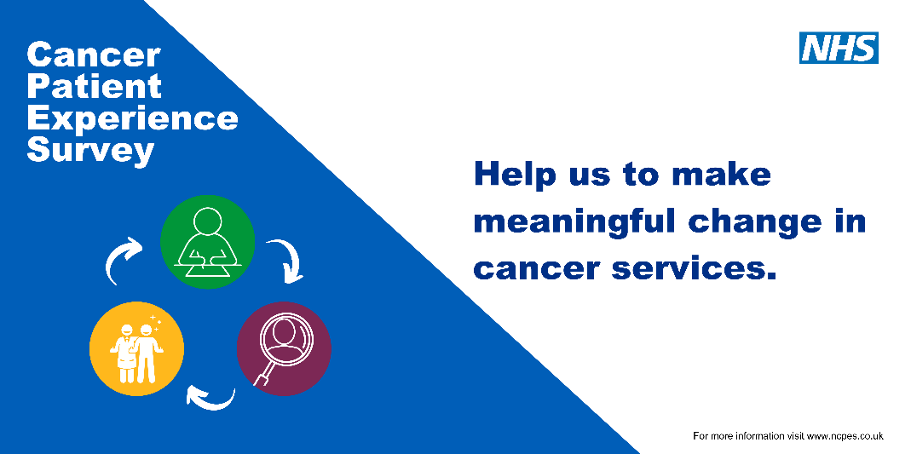
In the NHS we want our patients to have the best experience possible and having continuous patient feedback is crucial in helping us to deliver what patients want and need.
The national Cancer Patient Experience Survey (CPES) asks for feedback from cancer patients (16 years and over), to inform and improve local cancer services across England. Those who were treated for cancer as an inpatient or day case, and left hospital in April, May or June 2021, will be invited to take part in the survey.
For more information on the survey and how to access help and support in completing it, please follow this link: https://www.ncpes.co.uk/
In addition, a new survey has been launched for those aged 16 and under. To access the survey, click here.
Carers experience of Yorkshire Ambulance Service
Yorkshire Ambulance Service (YAS) has worked in collaboration with key stakeholders across Yorkshire and the Humber to create a survey to capture the views of carers across the area that have used the Yorkshire Ambulance Service, whether calling 111 or 999 or using the Patient Transport Service.
If this applies to you, or a carer that you know, YAS would like to hear from you. The results of the survey will help inform the needs of carers along with assisting YAS with contingency planning in the future.
You can complete the survey by visiting: https://survey.yas.nhs.uk/s/Experience-with-Yorkshire-Ambulance-Service/.
If you require additional support to complete the survey, paper copies can be provided or alternatively the survey can be completed over the phone if needed.
Please contact Laura Williams, Dementia Project Coordinator at YAS for further assistance:
Email: laura.williams47@nhs.net
Telephone: 07825 280185.
British Heart Foundation Cardiac Rehab, patient survey

Do you want to help to shape the future of cardiac rehabilitation services? If you, or anyone you know, have accessed or completed cardiac rehabilitation in the last 18 months, the British Heart Foundation would love to hear from you.
Please share your experience with them via their online survey: https://rtr.tolunastart.com/TrafficUI/MSCUI/Page.aspx?pgtid=19&cid=5&bid=10158&golsoid=24056926b43643ad8ca46f9b0d266990&

